A Recipe For:

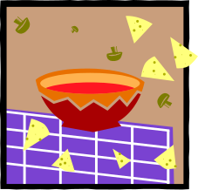

Yummy Granola

From the Kitchen of: Grandma Young
Servings: 6-8 cups
Prep Time: quick Bake Time: 20-25 min Bake Temp: 325

Ingredients:

- 2 1/2 cups Old Fashion Oats, uncooked, not instant
- ½ cups each of walnuts pecans and almonds
- 1 tsp cinnamon
- ½ tsp nutmeg
- ¼ tsp ginger
- 1/3 cup honey
- 1 tsp vanilla
- Syrup

In a measuring cup combine and stir together:
1/3 cup honey
Fill to half cup with syrup
1 tsp honey

Stir these together and add to dry mix. Stir together until dry mix is completely moistened. Lightly spray cookie sheet with Pam. Spread granola out and bake 10 minutes. Take it out, stir the granola around, spread back out and bake another 10 minutes.

Store in cool, dry place or in the refrigerator.

